|  |  |  |  |  |  |  |  |  |  |  |  |  |  |  |  |  |  |
| --- | --- | --- | --- | --- | --- | --- | --- | --- | --- | --- | --- | --- | --- | --- | --- | --- | --- |
|  |  |  |  |  |  |  |  |  |  |  |  |  |  |  |  |  |  |
|  |  |  |  |  |  |  |  |  |  |  |  |  |  |  |  |  |  |
|  |  |  |  |  |  |  |  |  |  |  |  |  |  |  |  |  |  |
|  |  |  |  |  |  |  |  |  |  |  |  |  |  |  |  |  |  |
|  |  |  |  |  |  |  |  |  |  |  |  |  |  |  |  |  |  |
| 18 17 16 15 14 13 12 11 21 22 23 24 25 26 27 28 |  |  |  |  |  |  |  |  |  |  |  |  |  |  |  |  |  |

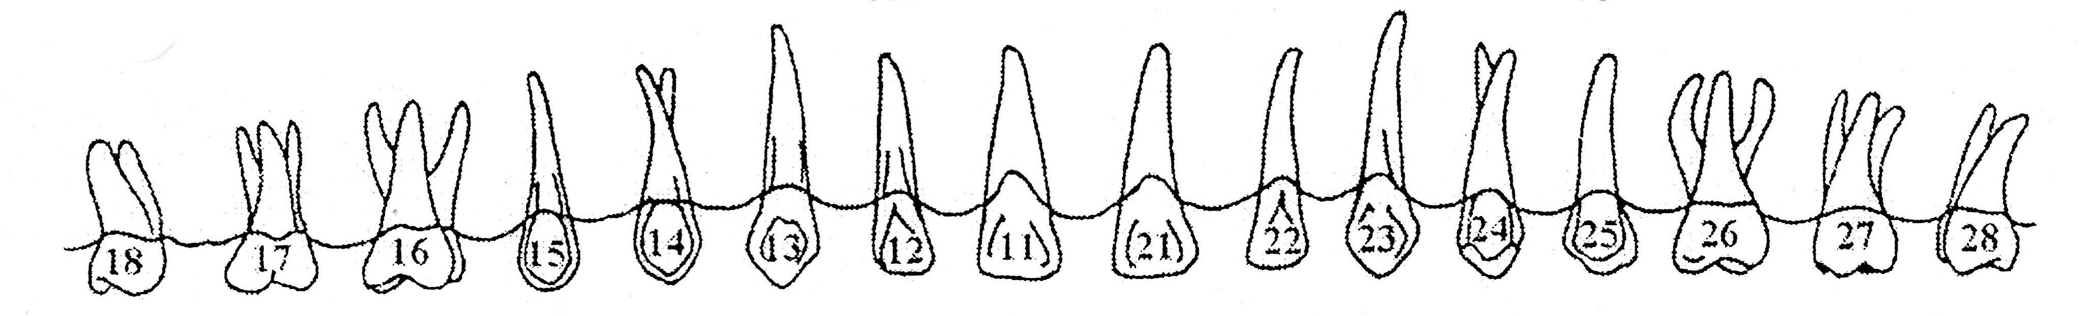

Nom : ______________________________________

B

B

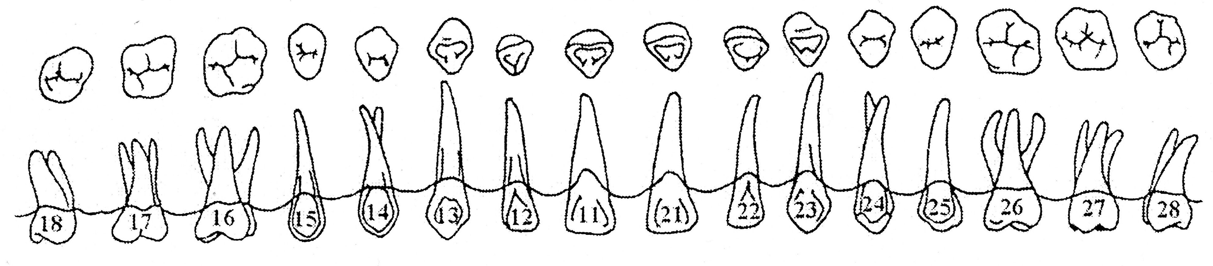

P

P

|  |  |  |  |  |  |  |  |  |  |  |  |  |  |  |  |  |  |
| --- | --- | --- | --- | --- | --- | --- | --- | --- | --- | --- | --- | --- | --- | --- | --- | --- | --- |
|  |  |  |  |  |  |  |  |  |  |  |  |  |  |  |  |  |  |
|  |  |  |  |  |  |  |  |  |  |  |  |  |  |  |  |  |  |
|  |  |  |  |  |  |  |  |  |  |  |  |  |  |  |  |  |  |
|  |  |  |  |  |  |  |  |  |  |  |  |  |  |  |  |  |  |
|  |  |  |  |  |  |  |  |  |  |  |  |  |  |  |  |  |  |
| 18 17 16 15 14 13 12 11 21 22 23 24 25 26 27 28 |  |  |  |  |  |  |  |  |  |  |  |  |  |  |  |  |  |

**********************************************************************************************

|  |  |  |  |  |  |  |  |  |  |  |  |  |  |  |  |  |  |
| --- | --- | --- | --- | --- | --- | --- | --- | --- | --- | --- | --- | --- | --- | --- | --- | --- | --- |
|  |  |  |  |  |  |  |  |  |  |  |  |  |  |  |  |  |  |
|  |  |  |  |  |  |  |  |  |  |  |  |  |  |  |  |  |  |
|  |  |  |  |  |  |  |  |  |  |  |  |  |  |  |  |  |  |
|  |  |  |  |  |  |  |  |  |  |  |  |  |  |  |  |  |  |
|  |  |  |  |  |  |  |  |  |  |  |  |  |  |  |  |  |  |
| 48 47 46 45 44 43 42 41 31 32 33 34 35 36 37 38 |  |  |  |  |  |  |  |  |  |  |  |  |  |  |  |  |  |

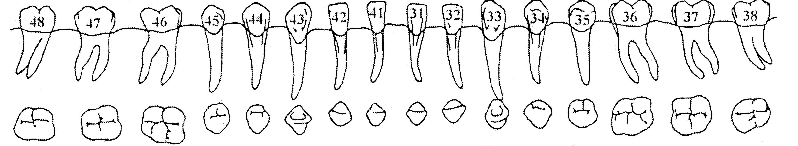

L

L

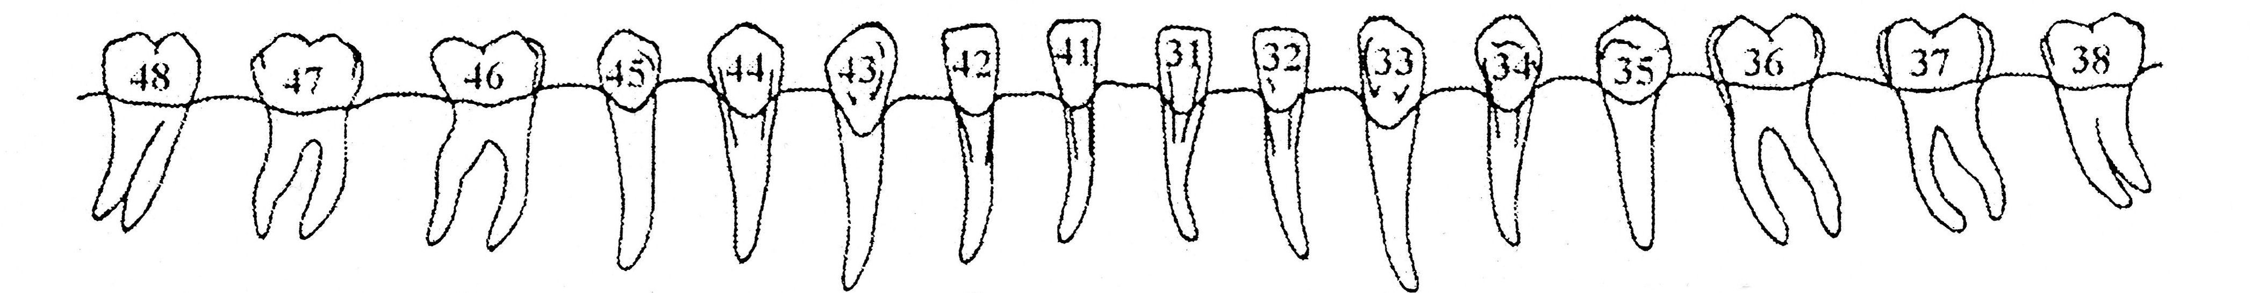

B

B

48 47 46 45 44 43 42 41 31 32 33 34 35 36 37 38

|  |  |  |  |  |  |  |  |  |  |  |  |  |  |  |  |  |  |
| --- | --- | --- | --- | --- | --- | --- | --- | --- | --- | --- | --- | --- | --- | --- | --- | --- | --- |
|  |  |  |  |  |  |  |  |  |  |  |  |  |  |  |  |  |  |
|  |  |  |  |  |  |  |  |  |  |  |  |  |  |  |  |  |  |
|  |  |  |  |  |  |  |  |  |  |  |  |  |  |  |  |  |  |
|  |  |  |  |  |  |  |  |  |  |  |  |  |  |  |  |  |  |
|  |  |  |  |  |  |  |  |  |  |  |  |  |  |  |  |  |  |
| 48 47 46 45 44 43 42 41 31 32 33 34 35 36 37 38 |  |  |  |  |  |  |  |  |  |  |  |  |  |  |  |  |  |