World Book Night
at Spalding Library
Thursday 26th April
3.30 pm – 6.00 pm
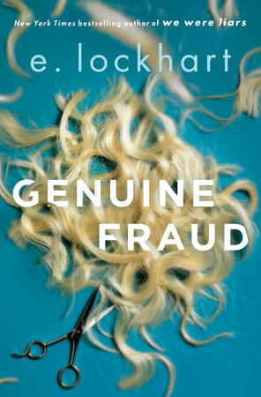
Come and collect your FREE book and join us for a cuppa to celebrate World Book Night!

