Peggy Seigler Tourism Excellence Award Nomination Form  Deadline: October 31, 2016 by 5:00 PM | 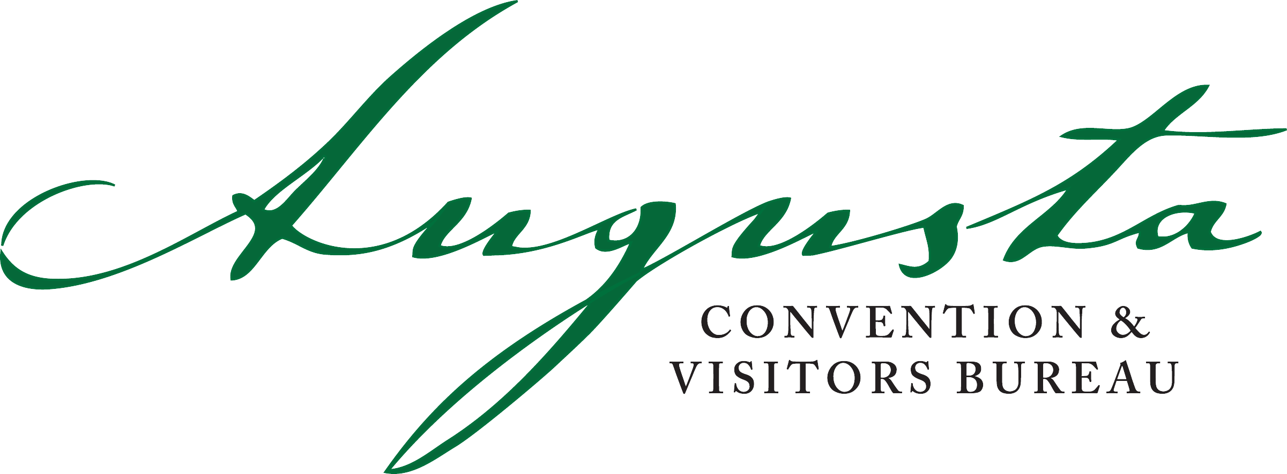

Nominee Information (Individual or Organization)
Individual Organization

Name
Organization
Mailing Address
Phone
Email Address

Nominator Information

Name
Organization
Mailing Address
Phone
Email Address

Essay (not to exceed 500 words)

Please provide an essay explaining how the individual or organization fits the following criteria.
- The level of contribution to the tourism industry, such as a significant economic impact, multiple years of contributions, the outcome of the contribution and its opportunity for benefits to the tourism industry, etc.
- The legacy of the contribution. What will people say about this individual, organization or program in 20 years as they recall the impact of this nominee to the tourism industry?
- The passion, enthusiasm, drive, momentum, team-building ability, etc. of the individual or organization as it relates to tourism industry accomplishments.
- What makes this nominee's contribution significant and outstanding to the tourism industry when compared to other tourism industry individuals or organizations?

Letters of Recommendation
Please provide at least two letters of recommendation from other supporters.

Submission Requirements
This nomination form declaring your nominee for the 2016 Peggy Seigler Tourism Excellence Award with supporting essay and two letters of recommendation must be submitted to the Augusta Convention & Visitors Bureau and received by 5:00 PM on Monday, October 31, 2016.

Augusta Convention & Visitors Bureau
Attention: Tourism Excellence Award
P.O. Box 1331
Augusta, GA 30903
Email: Deborah@VisitAugusta.com

For questions about the award process, please contact Deborah Dailey at 706.849.3246 or Deborah@VisitAugusta.com.

Signature

The individual submitting this nomination form will be the contact person for all future correspondence regarding the Tourism Excellence Award nomination.
Name (printed)
Signature
Date

