CRM Instructions
Extranet Login & Partner Bulletins

http://extranet.denver.simpleviewcrm.com

Logging In:
- You will receive an email from the VISIT DENVER with a URL link and a temporary password.
- Click on the link, which will take you to the “VISIT DENVER Extranet Login” screen.
- Type in your username, which is your full email address.
- Type in your password, which is the temporary one that was emailed to you.
- Upon logging in with your temporary password, you will be prompted to change your password to one of your preference.
  - If you are assigned to more than one member account (e.g. multiple hotels, restaurants, etc…), and have the same email address for each member account, you will be able to access all of your accounts with the same login credentials.
- If you ever have problems getting into your account, contact your account manager at VISIT DENVER for assistance.

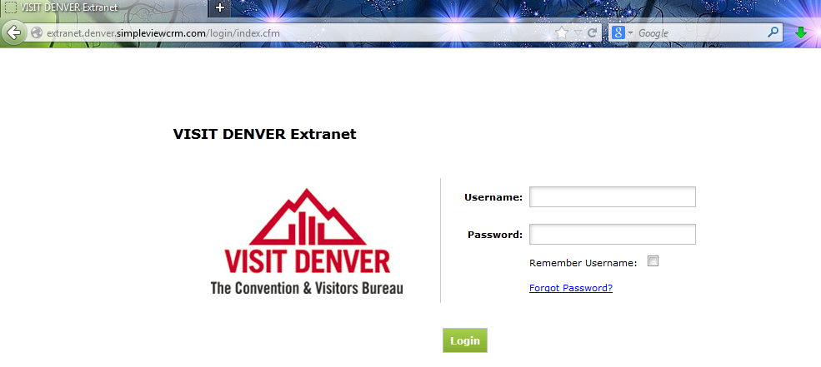
Once you have logged in, the default view is the “Partner Bulletins” tab; however, depending on your access levels, you will see various tabs available to view:
- Leads
- Member Record
- Service Requests
- Reports
- Partner Bulletins

NOTE: If you have access to view more than one account, you will see a dropdown in the upper right corner where you can switch back and forth between accounts.

Partner Bulletins:
- After successfully logging in, you will see the Partner Bulletins page. This is where VISIT DENVER will communicate partner information to you. Bulletins such as extranet documentation, event reminders, etc…
- You can search for bulletins in the keyword search on the left side of the page or select a category to view messages in specific categories.
- In the center of the page are the bulletins. This page gives you a brief summary of the bulletin and any attachments that pertain to the bulletin (attachments are denoted with a paperclip).
  - To the right of the bulletin title, it will indicate if you have read the bulletin and if so, give you the date it was read.

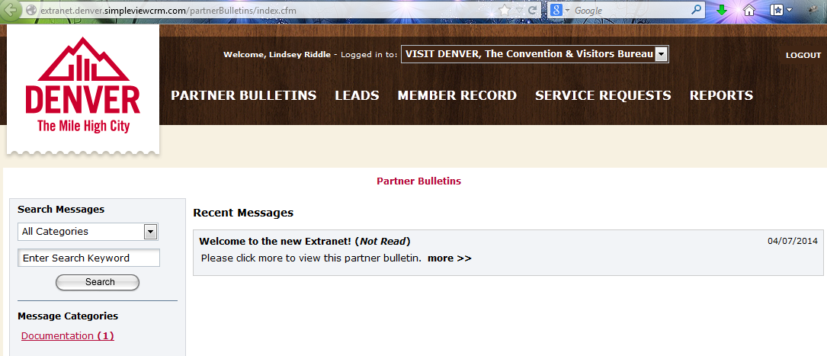
- To view the bulletin in more detail, click the “more >>” link at the end of the bulletin.
- When are finished reading the details of the bulletin, you can click the “Back to Recent Bulletins” button to be taken to the Bulletin home page.

