CRM Instructions
Updating Listings

http://extranet.denver.simpleviewcrm.com

Viewing Your Member Record
Depending on your access levels, there are various items that can be viewed under your Member Record:
- Listings

Listings:
- In order to update your listing, click the “Edit” icon to the left of the appropriate listing.
- Change your description.
- Your changes will go into a pending status until a representative from VISIT DENVER approves them. You cannot alter a listing that is pending approval.
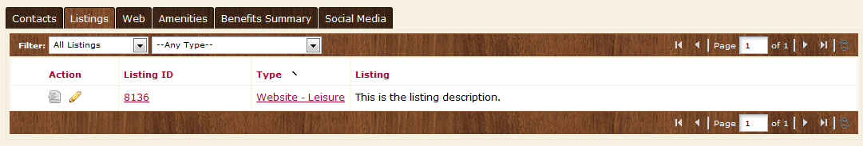
Editing a Listing:
- There are three types of listings:
  - Website – for the www.visitdenver.com website
  - Destination Planning Guide
  - Official Visitors Guide
- Contact Drop-down: This contact will be the main contact for your listing if we were to send a referral to a visitor or group.
- Address Type: Select “Physical” to display the main address on your account
- Listing: Enter descriptive text for your venue.
- Search Keywords: Enter keywords that can be used on the website to locate your listing in a search.
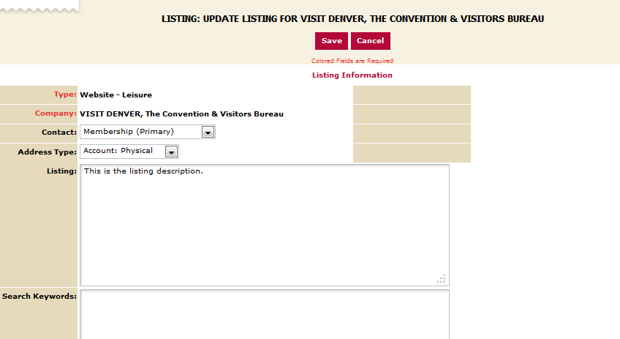

- Listing Details: This information will pull in from your Account Detail; however, by clicking the “Overwrite” box next to each field you may replace it with alternate text
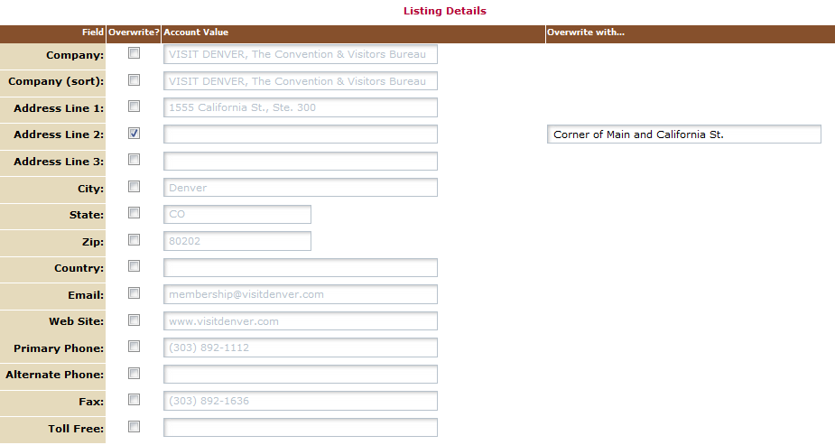

- Website Notifications: Enter any email addresses you would like to be notified with website listing view updates (how many times it has been viewed). You may select re-set intervals or enter a desired one.

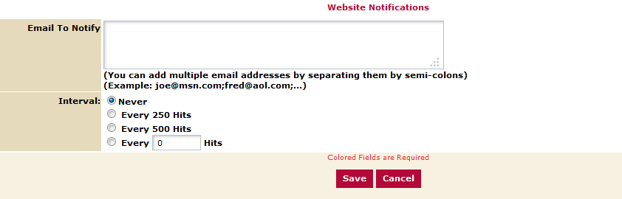

- Click the “Save” button when you are finished making any changes
- When you return to your listing screen, you will be able to tell that your listing changes are pending by seeing that the far left icon is no longer grayed out but blue and yellow

